**Appendix J:  
Economic Resilience Assessment**

**Cascades West Economic Development District**

# 

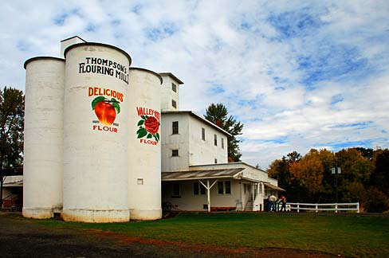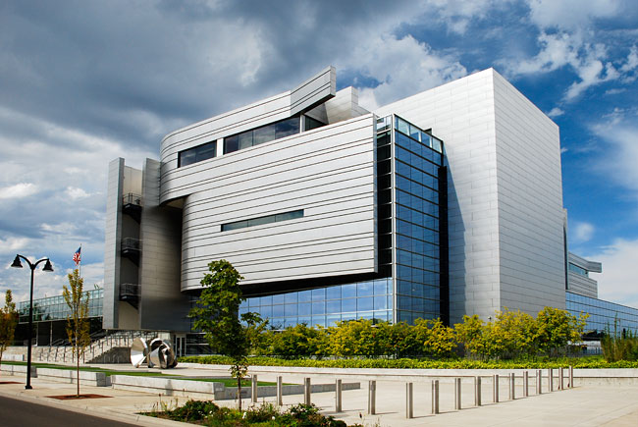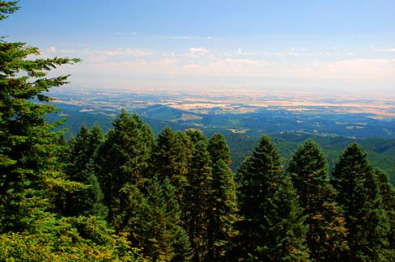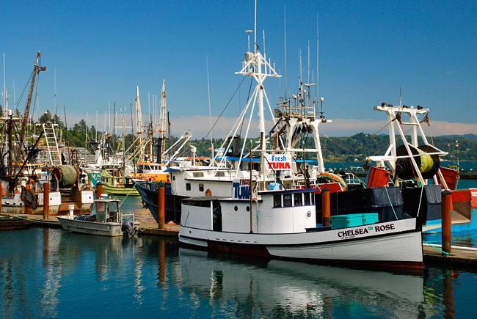

Photo Credits Gary Halvorson, Oregon State Archives

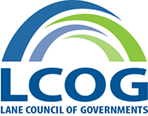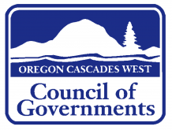

September 2016

June 2015

June 2015

June 2015

June 2015

June 2015

June 2015

June 2015

June 2015

June 2015

June 2015

June 2015

June 2015

June 2015

June 2015

June 2015

June 2015

June 2015

June 2015

June 2015

June 2015

June 2015

June 2015

June 2015

June 2015

June 2015

June 2015

June 2015

June 2015

June 2015

June 2015

June 2015

July 2015

June 2015

June 2015

June 2015

June 2015

June 2015

June 2015

June 2015

June 2015

June 2015

June 2015

June 2015

June 2015

June 2015

June 2015

June 2015

June 2015

June 2015

June 2015

June 2015

June 2015

June 2015

June 2015

June 2015

June 2015

June 2015

June 2015

June 2015

June 2015

June 2015

June 2015

June 2015

July 2015

June 2015

June 2015

June 2015

June 2015

June 2015

June 2015

June 2015

June 2015

June 2015

June 2015

June 2015

June 2015

June 2015

June 2015

June 2015

June 2015

June 2015

June 2015

June 2015

June 2015

June 2015

June 2015

June 2015

June 2015

June 2015

June 2015

June 2015

June 2015

June 2015

June 2015

June 2015

July 2015

June 2015

June 2015

June 2015

June 2015

June 2015

June 2015

June 2015

June 2015

June 2015

June 2015

June 2015

June 2015

June 2015

June 2015

June 2015

June 2015

June 2015

June 2015

June 2015

June 2015

June 2015

June 2015

June 2015

June 2015

June 2015

June 2015

June 2015

June 2015

June 2015

June 2015

June 2015

July 2015

June 2015

June 2015

June 2015

June 2015

June 2015

June 2015

June 2015

June 2015

June 2015

June 2015

June 2015

June 2015

June 2015

June 2015

June 2015

June 2015

June 2015

June 2015

June 2015

June 2015

June 2015

June 2015

June 2015

June 2015

June 2015

June 2015

June 2015

June 2015

June 2015

June 2015

June 2015

July 2015

June 2015

June 2015

June 2015

June 2015

June 2015

June 2015

June 2015

June 2015

June 2015

June 2015

June 2015

June 2015

June 2015

June 2015

June 2015

June 2015

June 2015

June 2015

June 2015

June 2015

June 2015

June 2015

June 2015

June 2015

June 2015

June 2015

June 2015

June 2015

June 2015

June 2015

June 2015

July 2015

June 2015

June 2015

June 2015

June 2015

June 2015

June 2015

June 2015

June 2015

June 2015

June 2015

June 2015

June 2015

June 2015

June 2015

June 2015

June 2015

June 2015

June 2015

June 2015

June 2015

June 2015

June 2015

June 2015

June 2015

June 2015

June 2015

June 2015

June 2015

June 2015

June 2015

June 2015

July 2015

June 2015

June 2015

June 2015

June 2015

June 2015

June 2015

June 2015

June 2015

June 2015

June 2015

June 2015

June 2015

June 2015

June 2015

June 2015

June 2015

June 2015

June 2015

June 2015

June 2015

June 2015

June 2015

June 2015

June 2015

June 2015

June 2015

June 2015

June 2015

June 2015

June 2015

June 2015

July 2015

June 2015

June 2015

June 2015

June 2015

June 2015

June 2015

June 2015

June 2015

June 2015

June 2015

June 2015

June 2015

June 2015

June 2015

June 2015

June 2015

June 2015

June 2015

June 2015

June 2015

June 2015

June 2015

June 2015

June 2015

June 2015

June 2015

June 2015

June 2015

June 2015

June 2015

June 2015

July 2015

June 2015

June 2015

June 2015

June 2015

June 2015

June 2015

June 2015

June 2015

June 2015

June 2015

June 2015

June 2015

June 2015

June 2015

June 2015

June 2015

June 2015

June 2015

June 2015

June 2015

June 2015

June 2015

June 2015

June 2015

June 2015

June 2015

June 2015

June 2015

June 2015

June 2015

June 2015

July 2015

June 2015

June 2015

June 2015

June 2015

June 2015

June 2015

June 2015

June 2015

June 2015

June 2015

June 2015

June 2015

June 2015

June 2015

June 2015

June 2015

June 2015

June 2015

June 2015

June 2015

June 2015

June 2015

June 2015

June 2015

June 2015

June 2015

June 2015

June 2015

June 2015

June 2015

June 2015

July 2015

June 2015

June 2015

June 2015

June 2015

June 2015

June 2015

June 2015

June 2015

June 2015

June 2015

June 2015

June 2015

June 2015

June 2015

June 2015

June 2015

June 2015

June 2015

June 2015

June 2015

June 2015

June 2015

June 2015

June 2015

June 2015

June 2015

June 2015

June 2015

June 2015

June 2015

June 2015

July 2015

June 2015

June 2015

June 2015

June 2015

June 2015

June 2015

June 2015

June 2015

June 2015

June 2015

June 2015

June 2015

June 2015

June 2015

June 2015

June 2015

June 2015

June 2015

June 2015

June 2015

June 2015

June 2015

June 2015

June 2015

June 2015

June 2015

June 2015

June 2015

June 2015

June 2015

June 2015

July 2015

June 2015

June 2015

June 2015

June 2015

June 2015

June 2015

June 2015

June 2015

June 2015

June 2015

June 2015

June 2015

June 2015

June 2015

June 2015

June 2015

June 2015

June 2015

June 2015

June 2015

June 2015

June 2015

June 2015

June 2015

June 2015

June 2015

June 2015

June 2015

June 2015

June 2015

June 2015

July 2015

June 2015

June 2015

June 2015

June 2015

June 2015

June 2015

June 2015

June 2015

June 2015

June 2015

June 2015

June 2015

June 2015

June 2015

June 2015

June 2015

June 2015

June 2015

June 2015

June 2015

June 2015

June 2015

June 2015

June 2015

June 2015

June 2015

June 2015

June 2015

June 2015

June 2015

June 2015

July 2015

June 2015

June 2015

June 2015

June 2015

June 2015

June 2015

June 2015

June 2015

June 2015

June 2015

June 2015

June 2015

June 2015

June 2015

June 2015

June 2015

June 2015

June 2015

June 2015

June 2015

June 2015

June 2015

June 2015

June 2015

June 2015

June 2015

June 2015

June 2015

June 2015

June 2015

June 2015

Prepared for:

**Cascades West Economic Development District**

Prepared by:

# Appendix

Final Report

Final Report

Final Report

Final Report

Final Report

Final Report

Final Report

Final Report

Final Report

Final Report

Final Report

Final Report

Final Report

Final Report

Final Report

Final Report

Final Report

Final Report

Final Report

Final Report

Final Report

Final Report

Final Report

Final Report

Final Report

Final Report

Final Report

Final Report

Final Report

Final Report

Final Report

Final Report

Final Report

Final Report

Final Report

Final Report

Final Report

Final Report

Final Report

Final Report

Final Report

Final Report

Final Report

Final Report

Final Report

Final Report

Final Report

Final Report

Final Report

Final Report

Final Report

Final Report

Final Report

Final Report

Final Report

Final Report

Final Report

Final Report

Final Report

Final Report

Final Report

Final Report

Final Report

Final Report

Final Report

Final Report

Final Report

Final Report

Final Report

Final Report

Final Report

Final Report

Final Report

Final Report

Final Report

Final Report

Final Report

Final Report

Final Report

Final Report

Final Report

Final Report

Final Report

Final Report

Final Report

Final Report

Final Report

Final Report

Final Report

Final Report

Final Report

Final Report

Final Report

Final Report

Final Report

Final Report

Final Report

Final Report

Final Report

Final Report

Final Report

Final Report

Final Report

Final Report

Final Report

Final Report

Final Report

Final Report

Final Report

Final Report

Final Report

Final Report

Final Report

Final Report

Final Report

Final Report

Final Report

Final Report

Final Report

Final Report

Final Report

Final Report

Final Report

Final Report

Final Report

Final Report

Final Report

Final Report

Final Report

Final Report

Final Report

Final Report

Final Report

Final Report

Final Report

Final Report

Final Report

Final Report

Final Report

Final Report

Final Report

Final Report

Final Report

Final Report

Final Report

Final Report

Final Report

Final Report

Final Report

Final Report

Final Report

Final Report

Final Report

Final Report

Final Report

Final Report

Final Report

Final Report

Final Report

Final Report

Final Report

Final Report

Final Report

Final Report

Final Report

Final Report

Final Report

Final Report

Final Report

Final Report

Final Report

Final Report

Final Report

Final Report

Final Report

Final Report

Final Report

Final Report

Final Report

Final Report

Final Report

Final Report

Final Report

Final Report

Final Report

Final Report

Final Report

Final Report

Final Report

Final Report

Final Report

Final Report

Final Report

Final Report

Final Report

Final Report

Final Report

Final Report

Final Report

Final Report

Final Report

Final Report

Final Report

Final Report

Final Report

Final Report

Final Report

Final Report

Final Report

Final Report

Final Report

Final Report

Final Report

Final Report

Final Report

Final Report

Final Report

Final Report

Final Report

Final Report

Final Report

Final Report

Final Report

Final Report

Final Report

Final Report

Final Report

Final Report

Final Report

Final Report

Final Report

Final Report

Final Report

Final Report

Final Report

Final Report

Final Report

Final Report

Final Report

Final Report

Final Report

Final Report

Final Report

Final Report

Final Report

Final Report

Final Report

Final Report

Final Report

Final Report

Final Report

Final Report

Final Report

Final Report

Final Report

Final Report

Final Report

Final Report

Final Report

Final Report

Final Report

Final Report

Final Report

Final Report

Final Report

Final Report

Final Report

Final Report

Final Report

Final Report

Final Report

Final Report

Final Report

Final Report

Final Report

Final Report

Final Report

Final Report

Final Report

Final Report

Final Report

Final Report

Final Report

Final Report

Final Report

Final Report

Final Report

Final Report

Final Report

Final Report

Final Report

Final Report

Final Report

Final Report

Final Report

Final Report

Final Report

Final Report

Final Report

Final Report

Final Report

Final Report

Final Report

Final Report

Final Report

Final Report

Final Report

Final Report

Final Report

Final Report

Final Report

Final Report

Final Report

Final Report

Final Report

Final Report

Final Report

Final Report

Final Report

Final Report

Final Report

Final Report

Final Report

Final Report

Final Report

Final Report

Final Report

Final Report

Final Report

Final Report

Final Report

Final Report

Final Report

Final Report

Final Report

Final Report

Final Report

Final Report

Final Report

Final Report

Final Report

Final Report

Final Report

Final Report

Final Report

Final Report

Final Report

Final Report

Final Report

Final Report

Final Report

Final Report

Final Report

Final Report

Final Report

Final Report

Final Report

Final Report

Final Report

Final Report

Final Report

Final Report

Final Report

Final Report

Final Report

Final Report

Final Report

Final Report

Final Report

Final Report

Final Report

Final Report

Final Report

Final Report

Final Report

Final Report

Final Report

Final Report

Final Report

Final Report

Final Report

Final Report

Final Report

Final Report

Final Report

Final Report

Final Report

Final Report

Final Report

Final Report

Final Report

Final Report

Final Report

Final Report

Final Report

Final Report

Final Report

Final Report

Final Report

Final Report

Final Report

Final Report

Final Report

Final Report

Final Report

Final Report

Final Report

Final Report

Final Report

Final Report

Final Report

Final Report

Final Report

Final Report

Final Report

Final Report

Final Report

Final Report

Final Report

Final Report

Final Report

Final Report

Final Report

Final Report

Final Report

Final Report

Final Report

Final Report

Final Report

Final Report

Final Report

Final Report

Final Report

Final Report

Final Report

Final Report

Final Report

Final Report

Final Report

Final Report

Final Report

Final Report

Final Report

Final Report

Final Report

Final Report

Final Report

Final Report

Final Report

Final Report

Final Report

Final Report

Final Report

Final Report

Final Report

Final Report

Final Report

Final Report

Final Report

Final Report

Final Report

Final Report

Final Report

Final Report

Final Report

Final Report

Final Report

Final Report

Final Report

Final Report

Final Report

Final Report

Final Report

Final Report

Final Report

Final Report

Final Report

Final Report

Final Report

Final Report

Final Report

Final Report

Final Report

Final Report

Final Report

Final Report

Final Report

Final Report

Final Report

Final Report

Final Report

Final Report

Final Report

Final Report

Final Report

Final Report

Final Report

Final Report

Final Report

Final Report

Final Report

Final Report

Final Report

Final Report

Final Report

Final Report

Final Report

Final Report

Final Report

Final Report

Final Report

This Appendix was prepared by –



With planning grant funding provided by the



U.S. Department of Commerce  
Economic Development Administration

and



U.S. Federal Emergency Management Agency

*This material is a result of tax-supported research and, as such, is not copyrightable. It may be freely reprinted with the customary crediting of the source.*

# Special Thanks & Acknowledgements

The Community Service Center’s Community Planning Workshop at the University of Oregon developed this Economic Resilience Appendix for use by the Cascades West Economic Development District, the Oregon Cascades West Council of Governments, and the Lane Council of Governments. The University of Oregon Economic Development Administration University Center and Oregon Partnership for Disaster Resilience provided technical and funding support.

## Cascades West Economic Development District Board and 2015-2020 CEDS Strategy Committee

* Anne Schuster, County Commissioner, Benton County
* Biff Traber, Mayor, City of Corvallis
* Bill Hall, County Commissioner, Lincoln County
* Bob Elliott, Council President, City of Lebanon
* Caroline Bauman, Executive Director, Economic Development Alliance of Lincoln County
* Chris Workman, City Manager, City of Philomath
* Dann Cutter, City Councilor, City of Waldport
* Faye Stewart, County Commissioner, Lane County
* Gary Marks, City Manager, City of Lebanon
* Greg James, Willamalane Parks and Recreation District
* John Pascone, Albany-Millersburg Economic Development Corporation President
* John Simpson, Commissioner, Eugene Water and Electric Board
* Marilee Woodrow, City Councilor, City of Springfield
* Pam Barlow-Lind, Tribal Planner, Confederated Tribes of Siletz Indians
* Ric Ingham, City Administrator, City of Veneta
* Rob Scoggin, Chairperson, Lane Economic Committee
* Sharon Konopa, Mayor, City of Albany
* Tom Nelson, Economic Development Manager, City of Corvallis
* Sherry Duerst-Higgins, Board Member, Lane Education Service District
* Susy Lacer, Board of Directors Vice President, Siuslaw Library District

## Oregon Cascades West Council of Governments

* Fred Abousleman, Executive Director
* Lydia George, Deputy Director
* Phil Warnock, Community and Economic Development, Director
* Seth Sherry, Community and Economic Development, Planner
* Emma Chavez, Community and Economic Development, Executive Administrative Assistant

## Lane Council of Governments

* Brenda Wilson, Executive Director
* Stephen Dignam, Economic Development Program Manager

## Oregon Regional Solutions

* Jackie Mikalonis, South Valley / Mid Coast Region Coordinator

## U.S. Department of Commerce Economic Development Administration

* David Porter, Oregon EDA Representative

## Community Planning Workshop

* Robert Parker, Community Service Center, Director
* Josh Bruce, Community Service Center, Project Advisor
* Craig Wiroll, Project Manager

## Additional Thanks:

To the Community Planning Workshop, Community Economic Development Strategy development team for completing the initial research and laying the groundwork for this appendix:

* Amanda D’Souza, Project Manager
* Blake Helm, Project Associate
* Dianna Skelly, Project Associate
* Fabio Ramos de Andrade, Project Associate
* Kelsey Zlevor, Project Associate

## About the Community Service Center

The Community Service Center (CSC), a research center affiliated with the Department of Planning, Public Policy, and Management at the University of Oregon, is an interdisciplinary organization that assists Oregon communities by providing planning and technical assistance to help solve local issues and improve the quality of life for Oregon residents. The role of the CSC is to link the skills, expertise, and innovation of higher education with the transportation, economic development, and environmental needs of communities and regions in the State of Oregon, thereby providing service to Oregon and learning opportunities to the students involved.

### About Community Planning Workshop

Community Planning Workshop (CPW) is an experiential service-learning program within the Department of Planning, Public Policy and Management at the University of Oregon. Students work in teams under the direction of faculty and Graduate Teaching Fellows to develop proposals, conduct research, analyze and evaluate alternatives, and make recommendations for possible solutions to planning problems in Oregon communities. The CPW model is unique in many respects, but is transferable to any institution that desires to link pedagogy with community service.

### About the EDA University Center

The University of Oregon (UO) Economic Development Administration University Center (EDAUC) is a partnership between the Community Service Center, the UO Department of Economics, the Oregon Small Business Development Center Network and UO faculty. The UO Center provides technical assistance to organizations throughout Oregon, with a focus on rural economic development. The UO EDAUC seeks to align local strategies to community needs, specifically with regards to building understanding of the benefits of sustainable practices and providing technical training to capitalize on economic opportunities related to those practices. The UO EDAUC is partially funded through a grant from the U.S. Department of Commerce, Economic Development Administration.

### About the Oregon Partnership for Disaster Resilience

The Oregon Partnership for Disaster Resilience (OPDR) is a coalition of public, private, and professional organizations working collectively toward the mission of creating a disaster-resilient and sustainable state. Developed and coordinated by the Community Service Center at the University of Oregon, the OPDRemploys a service-learning model to increase community capacity and enhance disaster safety and resilience statewide.

This page left intentionally blank.

# Table of Contents

Introduction and Background 1

Purpose 1

Background 3

Economic Benefits of Resilient Communities 4

Principles of Resilient Systems 7

Maintain Diversity and redundancy………………………………………………………………………7

Foster complex adoptive systems thinking……………………………………………………………..8

broaden participation…………………………………………………………………………………………10

Economic Resilience Assessment 12

Survey 12

Critical Supply Chain and Infrastructure Analysis 15

Economic Resilience Strategy 21

Recommendations 21

This page left intentionally blank.

# Introduction and Background

Resilience is more than a buzzword. Resilience and disaster recovery planning are economic imperatives in a modern economy, and more and more studies are showing the financial benefits.

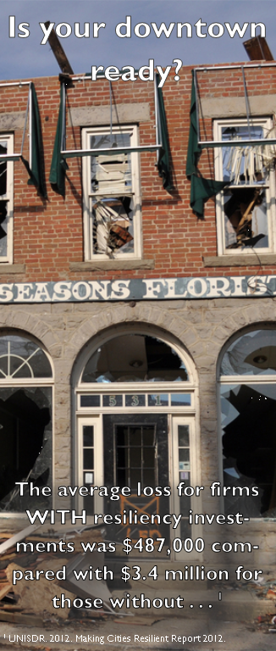The U.S. Department of Commerce’s Economic Development Administration (EDA) has developed updated guidelines for communities creating or updating a Comprehensive Economic Development Strategy (CEDS) as part of federal regulations that went into effect in early 2015. For the first time ever, EDA has included an economic resilience component in the updated guidelines. According to the National Association of Development Organizations (NADO), economic resilience is highlighted in a CEDS through “planning and implementing resilience, establishing information networks, conducting pre-disaster recovery planning, and measuring resilience.”[1]

## Purpose

The purpose of this Appendix is to bring together economic and hazard planning information to (1) assess the economic resilience of the region, (2) identify goals and objectives specific to economic resilience, and (3) identify a range of activities aimed at reducing risks to the regional economy.

Establishing economic resilience in a local or regional economy is paramount to overcoming and avoiding the negative impact of unavoidable shocks or threats. According to the Rural Policy Research Institute, “Shocks can include natural events, often but not always weather-related; human-made events, such as terrorism or nuclear or chemical accidents; medical events, such as pandemic diseases; and economic events, such as the collapse of an industrial sector or the cessation of a vital economic activity. These events may, and often do, occur in some combination, thus multiplying the impacts on a community or region.”[2] In this context, we also include impacts from emerging or evolving variables such as climate change, sea level rise, globalization, changes in technology, etc.. Resilience includes (1) anticipating potential risks, (2) knowing how those risks might impact your region economically, and (3) creating a detailed response to protecting those identified risk areas.

This Appendix helps identify regional vulnerabilities, and prevent and respond to economic disruptions. This is an important step in expanding economic development strategies to include potential major losses due to ill-prepared infrastructure and unidentified weaknesses in the supply chain. This involves surveying areas, such as energy plants and water supply facilities, and ensuring they are equipped to overcome disasters, deal with the changing climate, and be used as assets in times of emergency rather than liabilities.

Figure 1 shows a conceptual diagram of how the level of pre-event resilience contributes to level and length of time communities take to recover post event.

Figure 1: Community Resilience Pathways

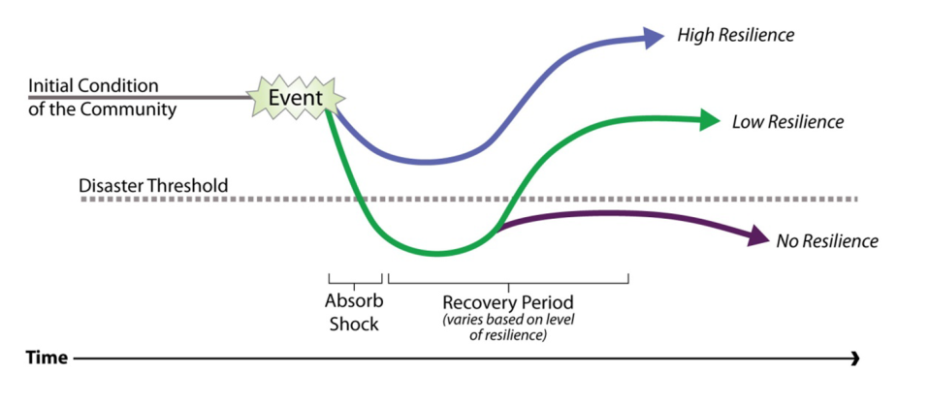Source: Oregon Partnership for Disaster Resilience

#### What is Economic Resilience?

**Economic resilience** includes three primary attributes: (1) the ability to recover quickly from a shock, (2) the ability to withstand a shock, and (3) the ability to avoid the shock altogether. Establishing economic resilience in a local or regional economy requires the ability to anticipate risk, evaluate how that risk can impact key economic assets, and build a responsive capacity. Often, the shocks/disruptions to the economic base of an area or region are manifested in three ways:

Downturns or other significant events in the national or international economy which impact demand for locally produced goods and consumer spending;

Downturns in particular industries that constitute a critical component of the region’s economic activity; and/or

Other external shocks (a natural or man-made disaster, closure of a military base, exit of a major employer, the impacts of climate change, etc.).

U.S. Department of Commerce Economic Development Administration (<http://www.eda.gov/ceds/content/economic-resilience.htm>

## Background

The International Economic Development Council (IEDC) is the world’s largest economic development membership organization. With funding from the EDA, the IEDC recently released a publication entitled “*Leadership in Times of Crisis: A Toolkit for Economic Recovery and Resiliency*.” The document concludes, in part, that individual business owners cannot be expected to prioritize disaster recovery or resilience. Rather, the publication strongly promotes the role of economic development organizations in spearheading efforts for greater economic resilience.

Notably, the publication explicitly promotes the establishment of relationships between economic development organizations and emergency management. The Cascades West Economic Development District (CWEDD) has expressed a strong desire to address economic resilience in the CEDS update process. CWEDD wants to be at the forefront of resilience planning so that the region can be prepared for the inevitable and also be able to react to the unexpected. This economic resilience assessment is intended to allow for reduced economic burden and better overall preparation in times of distress.

**Title 13, Chapter III, Part 303 of the Code of Federal Regulations** outlines the requirements for Planning Investments and Comprehensive Economic Development Strategies (CEDS). The regulations state that a CEDS must: “. . . promote Regional resiliency and be unique and responsive to the relevant Region.” According to EDA, all communities should evaluate their economic vulnerabilities and develop strategies to mitigate potential impacts to the regional economy. EDA suggests the following activities and projects:

* Identify persistent economic challenges or deficiencies:

What are the region’s economic vulnerabilities? Is there a singular issue or is it a more holistic problem? Is there a long-term plan for accessing economic vulnerabilities?

* Prepare for disruptions by identifying “early-warning” tools:

Will the region be able to react swiftly and efficiently in the event of a disaster? Is communication between economic development professionals and local/regional emergency managers efficient and active? Are there actuarial systems in place to monitor assessment efficiencies?

* Build mechanisms that create flexibility:

Do the local governments and major employers have access to “surge” capital/credit resources or funds available for emerging diverse economic sectors? Are there resources available to retrain and re-align workforces post-disruption?

* Promote a positive vision for the region:

Is there positive messaging about the region’s assets and opportunities? Do stakeholders understand that actions that build resilience are good for the regional economy? Are economic shocks used as an opportunity to “re-vision” and spark economic activity?

## Economic Benefits of Resilient Communities

Investments in hazard mitigation through supportive infrastructure, streamlined supply chains, and proper communication techniques have positive cost-benefit outcomes. According to the Multihazard Mitigation Council, a dollar spent on hazard mitigation saves society about $4 in future benefits.[3] Judith Rodin, President of the Rockefeller Foundation and author of the book *The Resilience Dividend*, argues that it costs 50% more to rebuild in the wake of a disaster than to build infrastructure to withstand the shock.[4]

The following sections summarize arguments that support making resilience-based investments. Ed MacMullan, economist at ECONorthwest, developed this summary following a review of economic literature and community resilience.

#### Fiduciary Responsibility

Government officials who manage taxpayer assets have a fiduciary responsibility to manage and invest funds wisely, and manage assets carefully. Natural and man-made disasters threaten these investments and assets. To the extent that private businesses rely on municipal investments and assets (e.g., roads, bridges, water supply, etc.), municipal investments and asset management can also affect the performance and success of local businesses. Prudent management of municipal investments and assets takes current information on risks of natural and manmade disasters into account when making future investments, or acquiring/constructing new assets (e.g., building a new school).[5]

#### Competitive Advantage or Disadvantage

As tsunami threats to the Oregon Coast become more well-known (As evidenced by the recent *New Yorker* article[6] on the Cascadia earthquake and tsunami) tourists and businesses may start comparing costal locations when making vacation and investment decisions. To the extent that tourists feel unsafe about vacationing in certain locations, they may avoid those areas and spend their vacation dollars elsewhere. Likewise, business owners and investors may have concerns over the security of investing in communities that lack a resiliency plan for their tsunami risks and make investments elsewhere. Coastal communities can increase their competitiveness for tourism and investment dollars by developing tsunami resilience measures and advertising these measures. They can use this information to distinguish themselves from other coastal communities that remain silent on the threats and their lack of response to those threats.[7] This rationale applies to other hazards in Oregon, such as floods, earthquakes, and wildfires.

#### Big Return On Resiliency Investments

Results from past investments show that municipal and business investments in resiliency actions pay big dividends in the form of avoided damages, costs and lost business activity.[8] Recent estimates of the benefit-cost ratios for resiliency investments, or the dollars of resiliency investments compared with the dollars of avoided damage, include the following:

* Federal Emergency Management Agency (FEMA) mitigation grants average 1:4; varies from 1:1.5 earthquake to 1:5 for flood mitigation.[9]
* United Nations Office of Disaster Risk Reduction calculated 1:10, or $10 of avoided direct and indirect damage for every $1 invested.[10]
* American Society of Civil Engineers calculates 1:6 for levees, and 1:3 to 1:4 for other flood control measures.9
* Orion utility company in New Zealand measured 1:10 after Christchurch earthquake.[11]

Studies conducted after natural disasters found that businesses that invested in resiliency measures suffered less economic loss compared with businesses that had not made such investments. The average economic loss for firms in the two categories was $478,000 loss for firms that invested in resiliency measures, and $3.4 million loss for firms that had not made such investments.[12]

Developing and implementing resiliency plans can also pay dividends by helping insurers assess a city’s level of risk and allow them to adjust premiums for well-prepared cities, or possibly write policies where none existed previously.[13]

#### Strengthen Local Economies

Results of studies of how natural disasters affect communities and organizations show that disasters accelerate existing pre-disaster economic and development trends.[14] Entities that were performing poorly before a disaster tended to have less capacity to cope with disruptions compared to those that were performing well.[15] Resiliency investments can help strengthen local economies by increasing spending in the local economy through hiring preferences for local workers and purchasing from local vendors.[16] Disaster risk reduction can also be a business opportunity for the private sector.[17]

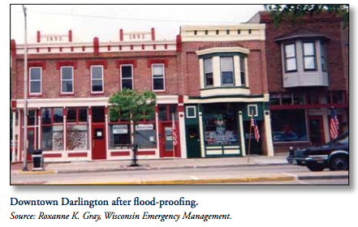

#### Darlington, WI Case Study

One story that speaks to the efficacy of economic resiliency is Darlington, Wisconsin. Darlington historically suffered from regular flooding, with large noteworthy floods occurring in 1950, 1959, 1969, and 1990. Finally, after the, “Great Flood of 1993”, in which 20-30 percent of the town was inundated, the City decided to take long-term action to develop a resilience plan to counter the negative economic effects. Mayor Bev Anderson, who spearheaded the effort, says “collaboration, cooperation, and coordination” were crucial to the program’s success. The multi-sector approach that Darlington and partners took has had a remarkable impact on the town. Rather than allowing it to deteriorate under the stress of repeated floods, it is now a tourist destination spot with a small, but vibrant downtown. As a result of the revitalization and flood mitigation, it is estimated that property values for commercial buildings along Main Street nearly doubled.

The success of Darlington didn’t happen by chance. It was a highly orchestrated plan consisting of a variety of collaborations and cross-sectoral resources. Success came from developing an interagency coalition for, “promoting the cooperation of government – local, state, and federal – and businesses.”

<http://www.nado.org/wp-content/uploads/2011/07/NADOResilientReport.pdf>

# Principles of Resilient Systems

One way to frame resilience is through a set of principles. Principles can apply across systems and are useful in establishing first-order considerations organizations can use when making decisions. Applied to economic development, resilience principles provide a framework for strategic investments and planning. In 2014, Cambridge University Press (2014) published, “*Principles for Building Resilience: Sustaining Ecosystem Services in Social-Ecological Systems*.”[18] The University of Oregon Community Service Center (CSC) adapted and distilled those seven principals into three primary principles focused on economic-development.

### Principle 1: Maintain Diversity and Redundancy

Diversity and redundancy can be summed up with the phrase, “don’t put all your eggs in one basket.” Diversity and redundancy can be thought of like an umbrella insurance policy that covers a disaster or natural hazard. In an economic sense, this strategy is routinely used by farmers who plant a diverse rotation of crops that hedges against the unexpected negative impact of crop failure. In the long run diversity and redundancy of systems will pay off when systems fail. Part of this philosophy is to ensure that linkages between systems are documented and that communication lines are established between systems. This will result in faster recovery from disturbances.

Does Economic Diversity Enhance Regional Disaster Resilience?

In 2013, Yu Xiao & Joshua Drucker conducted original research entitled, “*Does Economic Diversity Enhance Regional Disaster Resilience*?” Published in the Journal of the American Planning Association, Xiao and Drucker used the 1993 Midwest floods to discern between varying levels of economic resilience in relative to difference levels of in diversity within the affected communities. The researchers found that (1) economic diversity boosted employment growth and accelerated income recovery after the flood, allowing for quicker post-disaster recovery and resilience, and (2) that damaged areas lacking in economic diversity will likely experience larger setbacks in employment and income growth.

Xiao and Drucker, “Does Economic Diversity Enhance Regional Disaster Resilience?” *Journal of the American Planning Association*, Vol. 79, Iss. 2, 2013.

One of the key challenges is balancing the need for economic diversity and economic efficiency. According to the New Economics Foundation, a United Kingdom think tank, “beyond a certain point, increasing financial system activity may serve only to reduce resilience without any meaningful benefit to society.” Yu Xiao and Joshua Drucker in their paper, “*Does Economic Diversity Enhance Regional Disaster Resilience*?,” state:

“In normal times, diversity benefits employment growth but hampers income gains, a tradeoff that may reflect conflict between economic diversity and the efficiency advantages of specialization. We do not know yet how public policies or particular regional traits might diminish or negate this tradeoff. Planners and policymakers should consider these outcomes and recognize that some policies may represent compromises among different economic development aims. Ultimately, planners must understand that there are risks in designing policies that promote (or disregard) regional economic diversity.”[19]

The diagram in Figure 2 shows a visual representation of the optimal balance of resilience vs. efficiency. The goal in developing resilience programs is to remain as efficient as possible, while also being realistic that preparing for inevitable downturns and disasters does have an initial and ongoing investment cost. Being able to balance diverse and interconnected systems, without sacrificing efficiency, is the ultimate goal.

Figure 2: Optimizing efficiency and resilience  
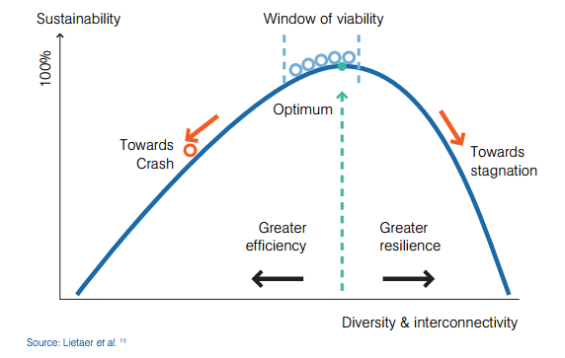

Source: New Economics Foundation[20]

### Principle 2: Foster Complex Adaptive Systems Thinking

Principle 1 implies that connections and interdependencies matter. In fact, the more diversity and redundancy in a community, the greater the “need to understand the complex interactions and dynamics that exist.”[21] In order to be most efficient in our diverse systems, coordination must occur across sectors and systems. Adopting a resilient and adaptive systems framework is important to anticipate and account for these interdependencies. The Stockholm Resilience Center cites several strategies for fostering complex adaptive systems thinking:

* **Adopt a systems framework.** This can help business owners and economic development professionals increase their understanding of interdependencies and relationships. For example, recognizing linkages between the private sector and public infrastructure, or between the economy and the environment.
* **Expect and account for change and uncertainty.** Businesses can employ scenario planning to explore and evaluate alternative economic development strategies, and to assess the intended and unintended consequences of different decisions. What happens to agriculture with a significant drought or other changes to the regional climate regime? How does a subduction zone earthquake impact the infrastructure that regional manufacturers rely on?
* **Recognize barriers to cognitive change.** Businesses, institutions, and organizations that could benefit from or capitalize on existing systems and approaches may resist adaptive systems thinking, particularly if it challenges a “business as usual” approach. For example, virtually all commerce and the infrastructure systems that support commerce in Oregon rely on fossil fuel. Roughly 90% of the state’s supply of fossil fuel is located in a single area north of Portland that is critically vulnerable to a large earthquake.

Bourne, MA Success Story

This case shows how public-private alliances, and creative thinking, can enhance both the local economy and local safety.

City leaders of Bourne, Massachusetts had wanted to revitalize their decaying downtown since the 1960s, but frequent coastal flooding and uncertain flood regulations had prevented developers from acting. Further, it was not physically or financially feasible to relocate the downtown. The economic development community generated more interest and buy-in to hazard mitigation than the town planner and emergency manager were able to do on their own. By treating the future of their downtown as an “open book,” working creatively with a large non-profit to re-imagine how new development could both reduce flooding hazards and inspire other owners, working to upgrade and expand wastewater treatment capacity that is a constraint on new business, and considering revolving loan funds and other means to reduce landowners’ redevelopment costs, the City is moving towards a brighter future for its downtown businesses.

[Source: Hazard Mitigation: Integrating Best Practices into Planning, Schwab, American Planning Association, 2010]

### Principle 3: Broaden Participation

One way to increase diversity and foster complex systems thinking is to invite more stakeholders and individuals to participate in the economic development process. Broad participation builds trust and creates a greater understanding. In addition, it has the potential to attract resources, perspectives, and solutions that might otherwise not be available. Important things to consider in engaging more people include: clarifying goals and expectations, getting the right people involved, finding leaders that can mobilize the group, providing capacity building, dealing with power issues and potential conflicts, and securing sufficient resources to enable effective participation.

The Stockholm Resilience Center presents several guidelines that can contribute to effective participation from a diverse set of stakeholders. While these are in no way groundbreaking, they are often overlooked:

* Clarify your goals and expectations of the participation process;
* Get the right people involved;
* Find inspired and motivated leaders that can mobilize the group;
* Provide capacity building;
* Deal with power issues and potential conflicts; and
* Secure sufficient resources to enable effective participation.

*100 Resilient Cities: A Resource*

The 100 Resilient Cities is an initiative pioneered and funded by The Rockefeller Foundation. The goal is to build capacity for a global network of cities dealing with similar and challenging resiliency issues from natural hazards to unemployment and violence. Cities in the 100 Resilient Cities network are provided with the resources necessary to develop a roadmap to resilience along four main pathways:

* Financial and logistical guidance for establishing an innovative new position in city government, a Chief Resilience Officer, who will lead the city’s resilience efforts;
* Expert support for development of a robust resilience strategy;
* Access to solutions, service providers, and partners from the private, public, and Non-Governmental Organization sectors who can help them develop and implement their resilience strategies; and
* Membership of a global network of member cities who can learn from and help each other.

[Rockefeller Foundation 100 Resilient Cities](http://www.100resilientcities.org/#/-_Yz41MTUzMSdpPTEocz5j/)

# Regional Economic Resilience Assessment

This resilience assessment strives to identify economic vulnerabilities that can inhibit short- and long-term economic recovery after a major disaster event. The assessment includes two primary steps: (1) a survey of local government representatives, economic development experts, and business representatives, and (2) a high-level analysis of critical supply chain linkages and infrastructure.

## Economic Development Stakeholder Survey

As part of the CEDS update process, CSC administered a survey to gauge perceptions of the strengths, weaknesses, opportunities, and threats in the region. Eighty-two stakeholders throughout the Benton, Lane, Lincoln, and Linn County region responded. Fifty-six percent of respondents reported that they represent the government sector, 24 percent represent private businesses, and 20 percent represent non-profit organizations.

The survey asked respondents to provide their input on specific questions related to economic resilience. We present a summary of the resilience related findings below. For the complete survey results, please refer to CEDS Appendix H.

#### Resilience Specific Survey Results

First, survey respondents report limited confidence that the region can withstand or recover from a shock. Nearly 70 percent of respondents indicated that they disagreed or strongly disagreed that the region *as it stands currently* can recover from a significant disruption or disaster event. Survey respondents also report strong support for consideration of resilience in economic development planning. Seventy-nine percent of respondents reported that it is slightly or very important for the region’s economic development strategy to consider business impacts resulting from *chronic* stresses (such as winter storms or workforce availability). Eighty-nine percent reported that it is slightly or very important for the CEDS to consider business impacts resulting from *catastrophic* events. These results suggest a significant gap between where respondents perceive the region is currently with respect to resilience and where it wants or needs to be.

Next, the survey asked respondents to indicate the extent to which characteristics commonly found in economically resilient communities are present in the CWEDD region. Selected responses are organized below by the three economic resilience principles: (1) maintain diversity and redundancy; (2) foster complex adaptive systems thinking; and (3) broaden participation.

#### Principle 1: Maintain Diversity and Redundancy

When asked if economic leaders actively identify local and regional partnerships that contribute to economic diversification, over half of the respondents agreed, some strongly, that this characteristic is present in the region. That economic diversity is a focus within the region is supported by data from the University of Illinois at Urbana-Champaign Regional Economic Applications Laboratory. Their research shows that the CWEDD region has a high to very-high levels of industry and occupational diversity across the four counties.[22]

However, when asked if economic development plans are well integrated into planning activities, 65 percent *disagreed* that this is happening. Ensuring that economic considerations are including in, for example, FEMA compliant Natural Hazard Mitigation Plans, is one way to ensure economic diversification goals are understood by local emergency managers. Further, such participation ensures that emergency managers have an opportunity to comment on economic development strategies and projects. The debate over OSU’s expansion of its Hatfield Marine Science Center in Newport is illustrative. On the one hand, the project represents significant potential economic gains for the City of Newport, Lincoln County, and the CWEDD. On the other hand, the addition of up to 500 additional students and faculty, and a huge investment of state money in the tsunami inundation zone will increase vulnerability in the South Beach area. The trade-offs associated with such decisions are complex. However, without intentional integration of economic, land-use, infrastructure and emergency management plans, communities can actually make large economic investments that actively reduce community and economic resilience.

#### Principle 2: Foster Complex Adaptive Systems Thinking

The survey asked about the extent to which organizational structures are in place to manage business response and recovery efforts. A strong majority of respondents (63 percent) *disagreed* that such structures are present. Similarly, 56 percent of respondents *disagree* that local funding mechanisms for post-disaster small business financing are available. This suggests that under Principle 2, the CWEDD could encourage systems (e.g. local recovery funding mechanisms) and structures (e.g. business recovery center(s)) that can support businesses following a disaster.

Notably, respondents split on their assessment of whether the region has implemented strategies to ensure infrastructure systems will be available following a disaster. Forty-percent of respondents *agree or strongly* agree and 48 percent disagree or *strongly disagree* that infrastructure systems will be available. Given the Oregon Resilience Plan’s assessment of critical infrastructure systems in the Willamette Valley, CWEDD can expect major disruptions to multiple critical infrastructure sectors including water, wastewater, transportation, electricity, communications, and emergency services. The survey findings suggest that for a large segment of the economic development community either (1) this information is not being communicated to economic development stakeholders or (2) members of the business community are not seeing a direct connection between the infrastructure systems that will be impacted and the business community’s reliance on those infrastructure systems. Either way, CWEDD can improve resilience by fostering regional understanding of the relationships between the public and private sector, how those relationships may need to adapt to changing threats in the region and how to embrace complexity in closing the “resilience gap.” Further, the private sector can and should actively participate in or co-lead local and regional Natural Hazard Mitigation Planning and Post-Disaster Recovery Planning activities.

#### Principle 3: Broaden Participation

One way to increase economic resilience is to ensure that members of the business community are following best-management practices, such as the preparation of business continuity plans. Notably, 67 percent of survey respondents indicated that businesses in the region are not actively preparing continuity plans to facilitate a quick recovery post disaster. A simple goal for the region then would be to increase the number of businesses that are developing business continuity plans. Numerous templates exist, including popular online resources through the Institute for Business and Home Safety’s *Open for Business* program.[23]

Another way to broaden participation is by ensuring participation from a wide range of stakeholders. For example, the survey asked respondents the extent to which they *agreed or disagreed* that “local funding mechanisms for post-disaster small business financing are available” and that “organizational structures are in place to manage business response and recovery efforts.” A majority of respondents (56 percent and 63 percent respectively) disagreed, some strongly, that such mechanisms and structures are in place. One strategy to address these issues could be to facilitate conversations with local/regional lending and financial institutions about how to provide emergency loans and gap funding to local businesses following a disaster.

Figure 3. Level of Agreement with Resilience Characteristics

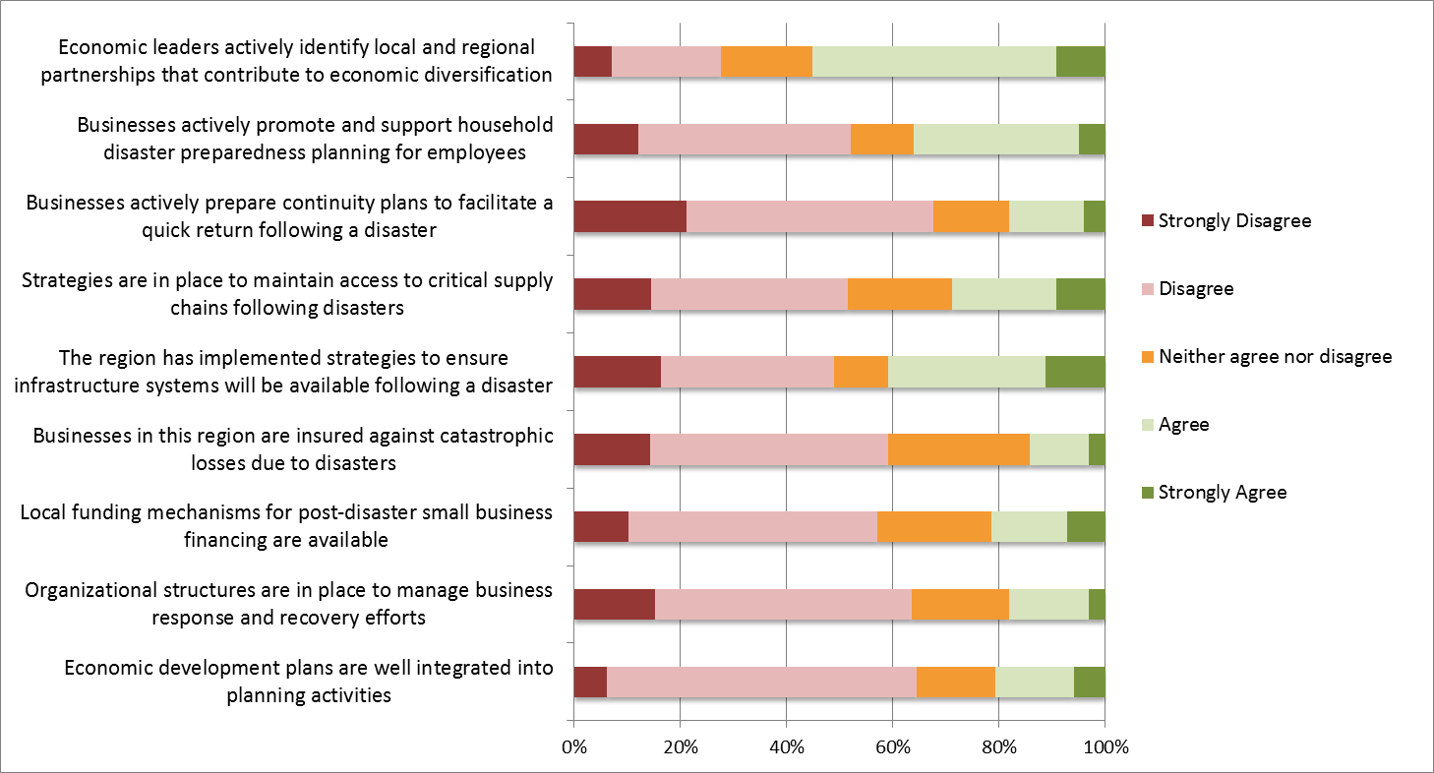

Source: 2015 CWEDD Stakeholder Survey

## Critical Supply Chain and Infrastructure Analysis

Disaster events can impact a range of private and public sector systems. Infrastructure, business, social, and environmental system impacts can result in impacts of interruptions to supply chains, workforce availability, distribution networks, communication systems, financial institutions, and wholesale/retail markets. Further, disasters can contribute to decreased production capacities, irregular cash flows, and an inability to transfer goods and services compared to times of strong economic health. Figures 4 and 5 show the types, probability, and vulnerability of natural hazards in the CWEDD by county. Chronic hazards, including flood, landslide, wildfire, and severe storms regularly impact transportation, electricity, and communication systems throughout the region with consequential impacts across a range of business sectors. Catastrophic hazards of concern in the region include earthquake, tsunami, and volcano.

Figure 4. Critical Threats & Vulnerabilities: Linn and Lane Counties



Sources Lane 2015 Oregon Emergency Management Threat Assessment; Linn 2006 Oregon Emergency Management Threat Assessment

Figure 5. Critical Threats & Vulnerabilities: Lincoln and Benton Counties



Sources: Benton 2015 Natural Hazard Mitigation Plan; Lincoln 2014 Natural Hazard Mitigation Plan

In order to mitigate economic losses in times of distress, an understanding and assessment of the supply chains and infrastructure linkages is needed. The Oregon Resilience Plan (ORP) completed in 2013, “. . . reviews policy options, summarizes relevant reports and studies by state agencies, and makes recommendations on policy direction to protect lives and keep commerce flowing during and after a Cascadia earthquake and tsunami.” The ORP bases its assessment on the assumption the business can only tolerate two to four weeks of disruption. The plan (1) analyzes likely impacts of a 9.0 Cascadia earthquake and tsunami on a range of sectors, (2) defines acceptable timeframes to restore functions after an earthquake, and (3) recommend changes in practice and policies that will allow Oregon to reach desired resilience targets.

Figure 4 summarizes ORP findings with respect to key Willamette Valley and coastal infrastructure sectors.

Figure 6. Current Resilience Gap for Lifeline Infrastructure

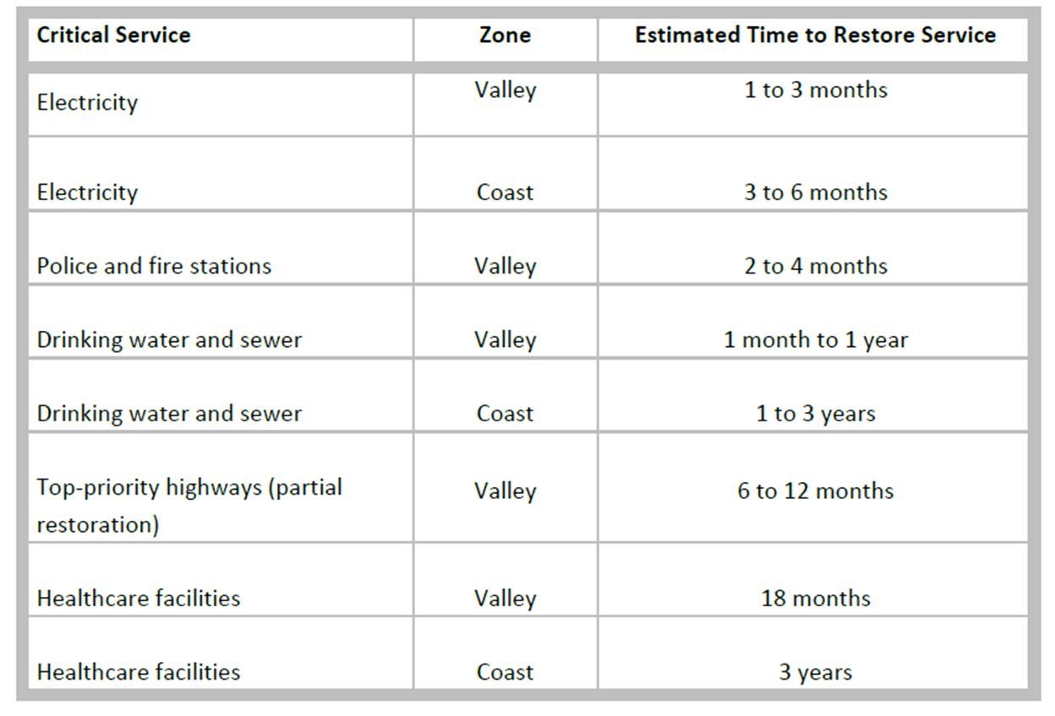

Sources: Oregon Resilience Plan

### Key Industry Clusters

As outlined in CEDS Appendix C, the majority of industry clusters in the CWEDD are related to available natural resources - forestry, fishing, agriculture, and tourism. Manufacturing, high tech industry, and government employment complete the list. Cluster classification in the CEDS is primarily sourced through clustermapping.us except where noted. The CWEDD Critical Supply Chain and Infrastructure Analysis focuses is organized around major regional industry clusters and focuses on four critical infrastructure sectors: (1) transportation; (2) energy; (3) communication; and (4) fuel.

#### Forest Products

While declines in harvest rates have impacted forest products over the past three decades or more, the sector remains an import part of the regional economy. Growing efficiencies and diversity in the forest products sector has increased its resilience by moderating some of the cyclic slumps and price swings evident in other industrial sectors.

##### Supply Chain and Infrastructure Dependence

The forest supply chain consists primarily of harvestable tree stands, primary wood processing facilities (such as saw or pulp mills), secondary wood processing facilities (such as structural wood products or paper products facilities), distribution, and wholesale/retail sales. The forest products sector relies primarily on the following critical infrastructure categories:

* Transportation, primarily roadway, rail, and marine
* Fuel, for harvest and transport
* Energy, for primary and secondary processing

#### Commercial Fisheries

Commercial fishing represents an important economic sector in the CWEDD. While economic activity is concentrated in Lincoln County, the sector represents significant economic activity in the CWEDD. The Port of Newport, for example, hosts more than 200 commercial vessel slips, 54 waterway related businesses, and a distant water fleet that annually brings in between $14 million and $32 million to the local economy.

##### Supply Chain and Infrastructure Dependence

The commercial fishing supply chain consists of access to viable fisheries; collection and primary processing facilities; secondary processing and value added products; distribution; and wholesale/retail sales. The fisheries sector relies primarily on the following critical infrastructure categories:

* Transportation, primarily marine, and roadway
* Fuel, for harvest and transport
* Energy, for primary and secondary processing

#### Agriculture

Agriculture is a dominant and visible sector in the CWEDD, particularly west of the Cascades. While crop diversity in the region has decreased significantly since the middle of the 20th century (with grass seed replacing many food crops for example), crop production remains strong. Notably, much of the food processing and storage infrastructure common in the region 50-years ago has been dismantled.

##### Supply Chain and Infrastructure Dependence

The agriculture sector supply chain generally consists of producers (i.e. farms and ranches), aggregation and trade, primary processing, secondary processing and wholesale/retail markets. Importantly, many food-related agriculture products are aggregated and shipped outside the region for processing. The agriculture sector relies primarily on the following critical infrastructure categories:

* Transportation, primarily roadway, rail, and marine
* Fuel, for production and transport

#### Tourism

Tourism is a strong and growing sector across the CWEDD. The sector supports significant employment, particularly in Lincoln County where 42% of the employment is tourism related. However, many jobs in this sector tend to be lower paying. Attractions in the region include the Oregon Coast, wineries, sporting events at the two universities, outdoor pursuits and the arts.

##### Supply Chain and Infrastructure Dependence

The tourism supply chain primarily consists of tangible (destinations and services) and intangible (atmosphere and experience) attractions, consumers with disposable income, and service providers. The tourism sector relies primarily on the following critical infrastructure categories:

* Transportation, primarily roadway, and aviation
* Fuel, primarily transportation
* Communication, to support service economy and transactions
* Energy, for service sector

#### High Tech

The high-tech sector is holds a prominent economic position in the region east of the coast range. Wages in this sector are higher than in many others. However, the job market is relatively unstable with large losses in the 2000’s contributing to a significant decline in employment over the last decade.

##### Supply Chain and Infrastructure Dependence

The high-tech sector supply chain primarily consists of raw materials, foundries, fabricators, inventory hubs, distribution, designers, manufactures, and retailers. Not included in the infrastructure list below is water, which is critical to many high-tech firms. In the OCWEDD, the high-tech sector relies primarily on the following critical infrastructure categories:

* Transportation, primarily roadway, rail, and aviation
* Fuel, primarily transportation
* Communication
* Energy, primarily for manufacture

#### Metals Manufacturing

Metals manufacturing is also concentrated east of the coast range with most of the activity occurring in Linn and Lane counties. Like high-tech, wages in this sector tend to be higher than others. Several of the region’s manufactures are the only source for their product in the Western United States.

##### Supply Chain and Infrastructure Dependence

The metal manufacture supply chain primarily consists of raw materials, foundries, fabricators, distribution, wholesale and retail. In the CWEDD, the high-tech sector relies primarily on the following critical infrastructure categories:

* Transportation, including roadway, rail, marine, and aviation
* Fuel, primarily transportation related
* Communication
* Energy, primarily for manufacture

# Regional Economic Resilience Strategy

This section presents a set of recommendations OCWEDD can use as a starting point to prioritize economic resilience activities in the region. The recommendations are framed around the three key principles of resilience. Basic, intermediate and advanced options are presented. Activities are not limited to CWEDD staff—all economic development professionals in the region should be pushing for a more resilient economy. It is not a matter of if the next shock comes—just a matter of when.

## Recommendations[24]

#### Basic Steps - Little to No Cost Actions to Take Right Now

##### Diversity and Redundancy

* Inventory local businesses capable of providing services, material, equipment, and workforce needed in the event of a catastrophe.
* Establish roles and responsibilities that economic development stakeholders in the region will need to fulfill following an economic shock or natural disaster.

##### Systems Thinking

* Involve economic development professionals and business representatives in emergency preparation, response, mitigation, and recovery planning activities.
* Promote the incorporation of recommendations from County and City Hazard Mitigation Plans into Economic Development Plans and Strategies.
* Encourage counties and cities in the region to adopt local recovery ordinances.

##### Broaden Participation

* Form a business continuity and disaster recovery working group.
* Encourage businesses to develop, test and implement business continuity plans.
* Discuss potential shocks, threats, disasters and risk reduction strategies at local chamber or business association “Lunch and Learn” events.

#### Intermediate Steps - Investing In Tomorrow

##### Diversity and Redundancy

* Establish a process to solicit, pre-approve and contract with local businesses, contractors and vendors for services, materials and equipment following a disaster.
* Partner with local businesses throughout the region to form an Economic Recovery Response Team.
* Ensure that economic development organizations, chambers of commerce, and business associations have arranged for alternate or backup office locations.

##### Systems Thinking

* Develop an economic recovery plan for the region.
* Update the economic development section of local comprehensive plans to include economic resilience considerations.
* Utilize external funding (such as the FEMA Hazard Mitigation Grant Program) as a way to leverage local funds for business-related mitigation activities. Or consider using Community Development Block Grants to retrofit buildings, elevate critical equipment or build to higher code standards.

##### Broaden Participation

* Partner with local businesses throughout the region to form an Economic Recovery Response Team.
* Incentivize investments in business resilience for businesses that have business continuity plans (e.g. reduce business license fees; 1% reduction in property taxes (or other tax) for businesses that have an employee preparedness training program; expedite plan review for hazard retrofit/mitigation projects).

#### Advanced Steps - Lead By Example

##### Diversity and Redundancy

* In cooperation with large employers, business clusters, or dense commercial areas located within hazard zones, develop strategy to harden, elevate, re-locate or otherwise mitigate / prevent damage from natural hazards.
* Invest in diverse and redundant critical infrastructure systems (e.g. transportation, fuel, energy, communications, water, etc.).
* Prepare to establish a Business Recovery Center within one- to two-weeks of a major economic shock or natural disaster.

##### Systems Thinking

* Use creative financing, such as revolving loan funds, grants and tax relief to help businesses reduce risk.
* Promote economic resilience activities as a way to market the region and encourage local investment and entrepreneurship.

##### Broaden Participation

* Promote creation of local disaster recovery plans: This can be used to set goals and guide business’ resiliency efforts within a documented and coherent strategy. This course of action will more effectively protect economic development efforts.

1. <http://www.nado.org/integrating-resilience-into-the-ceds/>
2. Dabson, B. 2012. “Regional Resilience Research and Policy Brief,” Rural Policy Research Institute (RUPRI) Rural Futures Lab, Harry S Truman School of Public Affairs, University of Missouri, Page 9.
3. The Multihazard Mitigation Council, *Natural Hazard Mitigation Saves: An Independent Study to Assess the Future Savings from Mitigation Activities. Volume 1 — Findings, Conclusions, and Recommendations,* National Institute of Building Sciences, Washington, D. C., 2005.
4. Rodin, J. 2014, January 22. Realizing the Resilience Dividend [Web log post]. The Rockefeller Foundation. Retrieved from http://www.rockefellerfoundation.org/blog/realizing-resilience-dividend.
5. Rosenberg, M. 2014. “Insurer’s Climate Change Class Actions: More to Come?” Insurance Journal. <http://www.insurancejournal.com>. May 19; Grosvenor. 2014. Resilient Cities. A Grosvenor Research Report.
6. Kathryn Schulz, “The Really Big One,” *New Yorker*, July 20, 2015.
7. Tjandradewi, B.I. 2013. Towards a post-2015 framework for disaster risk reduction. Building the resilience of nations and communities to disasters. Post-2015 Framework Website Blog <http://www.preventionweb.net/postfa/dialogue/discussion/26/>. March; Stevenson. J. 2014. Organisational resilience after the Canterbury earthquakes; a contextual approach. A thesis submitted in partial fulfillment of the requirements for the Degree of Doctor of Philsophy in Geography at the University of Canterbury; UNISDR. 2012. How to Make Cities More Resilient A Handbook for Local Government Leaders. A contribution to the Global Campaign 2010-2015 Making Cities Resilient ­ My City is Getting Ready!. Geneva. March.
8. The Multihazard Mitigation Council. 2005. Natural Hazard Mitigation Saves: An Independent Study to Assess the Future Savings from Mitigation Activities. Volume 1 — Findings, Conclusions, and Recommendations. National Institute of Building Sciences. Washington, D. C.
9. Rose, A., et al. 2007. “Benefit-Cost Analysis of FEMA Hazard Mitigation Grants,” Natural Hazards Review. November, pages 97-111.
10. Wimmers, A. 2014. “Building the Business Case for Resilience Investment,” Insight Magazine. KPMG International Cooperative.
11. Wimmers, 2014.
12. UNISDR. 2012. *Making Cities Resilient Report 2012*. [www.unisdr.org/campaign](http://www.unisdr.org/campaign). October.
13. UNISDR. 2012. *How to Make Cities* *More Resilient A Handbook for Local Government Leaders.* 
14. Colten, C., R. Kates, and S. Laska. 2008. *Community Resilience: Lessons from New Orleans and Hurricane Katrina*. Community & Regional Resilience Initiative. CARRI Report 3. September.
15. Stevenson, 2014.
16. UNISDR. 2012. *How to Make Cities* *More Resilient A Handbook for Local Government Leaders.*
17. UNISDR. 2012. *Making Cities Resilient Report 2012.* 
18. Simonsen, et al. *Applying Resilience Thinking Seven Principles for Building Resilience in Social-Ecological Systems*. Stockholm Resilience Center.
19. Xiao and Drucker, “Does Economic Diversity Enhance Regional Disaster Resilience?” *Journal of the American Planning Association*, Vol. 79, Iss. 2, 2013.
20. Lietaer et al., “Money and Sustainability: The missing link,” A report from the Club of Rome – EU Chapter to Finance Watch and the World Business Academy. Axminster: Triarchy Press, 2012: figure reproduced in Berry et al., “Financial System Resilience Index: Building a strong financial system,” a publication of the New Economics Foundation, 2015. (<http://b.3cdn.net/nefoundation/3898c6a7f83389375a_y1m6ixqbv.pdf>)
21. Ibid
22. *Economic Diversity in Appalachia*, 2014, University of Illinois at Urbana-Champaign Regional Economic Applications Laboratory and the Center for Regional Economic Competitiveness. Website: http://economicdiversityinappalachia.creconline.org/.
23. http://disastersafety.org/ibhs-business-protection/ofb-ez-business-continuity/
24. These recommendations are informed by: (1) training materials for decision makers developed by Community Service Center (CSC) in partnership with Dr. Branden Johnson at Decision Research and Ed MacMullan, Economist at ECONorthwest. CSC adapted and modified some of the recommendations to better address conditions in the Cascades West Economic Development District. (2) The EDA and IEDC funded website [restoreyoureconomy.org](http://restoreyoureconomy.org/).